NWBT Project Configuration

1. From the Admin menu, choose Site > Create Project. Give the project a name and choose the folder type "NW BioTrust Research Coordinator"

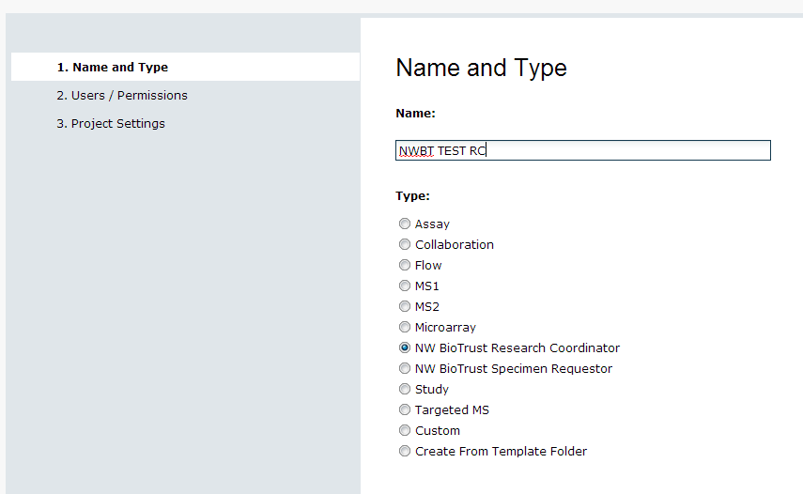

1. From the Admin menu, select Go To Module > Query and select the “survey” schema
2. From the “survey” schema, select the “Surveys” table and click the “create definition” link
3. Click the “Add Field” button and give the field a name of “Category” and a type that is a lookup to the biotrust.RequestCategory table
4. Click the “Add Field” button again and give the field a name of “Registered” and a type of DateTime and save
5. From the project RC folder, click on the “Manage” tab
6. From the “Manage Sample Request Lookup Tables” section, click on the “Document Types” link to populate it with the following data:

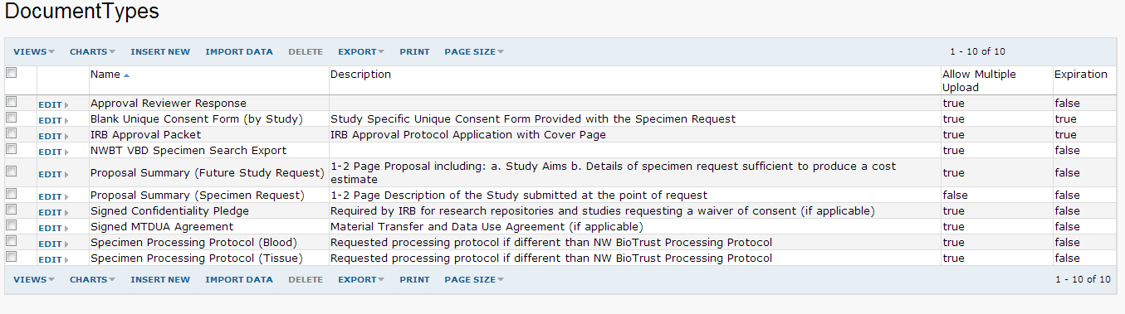

1. From the “Manage Sample Request Lookup Tables” section, click on the “Request Category” link to populate it with the following data:

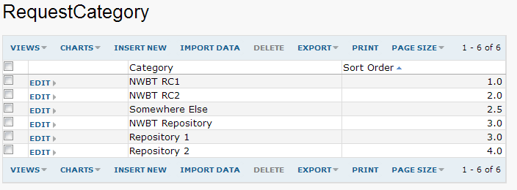

1. From the “Manage Sample Request Lookup Tables” section, click on the “Request Status” link to populate it with the following data:

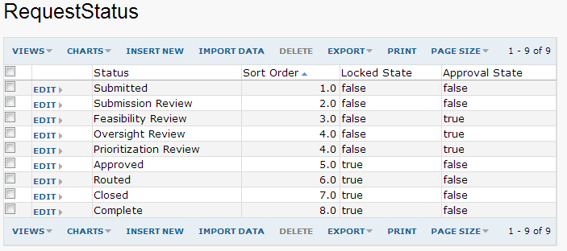

1. In the Survey Designs webpart on the Manage tab, create the following new survey designs (note: you can download the metadata file to use for each from the Manage tab “Metadata for Study Registration and Sample Requests” section):

|  |  |  |  |
| --- | --- | --- | --- |
| **Label** | **Schema** | **Query** | **Metadata File** |
| StudyRegistration | biotrust | StudyRegistrations | Study Registration |
| SampleRequest | biotrust | SampleRequests | Sample Request |
| TissueSample | biotrust | TissueRecords | Tissue Sample Record |
| BloodSample | biotrust | TissueRecords | Blood Sample Record |

You should end up with the following list of survey designs (which are used for the various study registration, sample request, and tissue record wizards)

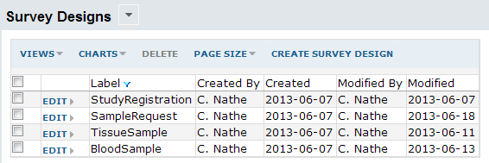

1. From the manage tab “Metadata for Contacts Fields” section, download the “Contacts fields” file
2. From the Admin menu, select Site > Site Users, and click the “Change User Properties” button
3. Populate the Users table fields based on the “Contacts fields” metadata file
4. Go back to the NWBT project RC folder, click the “New Sample Requests” tab
5. Click the “down arrow” icon next to the “RC Dashboard – New Sample Requests” webpart title and select “Customize”
6. Select the “StudyRegistration” title checkbox and save
7. Set up the anatomical site list : From the NWBT project manage tab, click on the Anatomical Site link. This will download a list archive to your local computer. Select the menu Admin->Manage Lists, and click on the import list archive button. Select the downloaded file, this should create a single list named : anatomicalsite. This is used in the sample request api to pull in the SNOMED-CT codes for the selected anatomical site for that sample.

# Configuring the default landing page

These are the instructions for configuring the default page that a user is redirected to so that if they have an account and their account is configured (investigator or RC), they automatically get redirected to their proper folder. Else, they will see the standard home page with instructions on how to request an account.

There are 2 possible methods:

1. Use the extraWebapp functionality:
   1. create the directory LABKEY_HOME/extraWebapp
   2. copy LABKEY_HOME/labkeywebapp/index.html to LABKEY_HOME/extraWebapp/index.html
   3. change the URL "./project/home/start.view" in the file to be "./biotrust/home/userHome.view"
   4. restart their tomcat server
2. Update LABKEY_HOME/labkeywebapp/index.html file
   1. change the URL "./project/home/start.view" in the file to be "./biotrust/home/userHome.view"
   2. restart their tomcat server

Method #1 is probably better because it doesn't require the default index.html to be re-edited each time a new release is deployed.